Splitting Forecasted Workload by Typology

Project Resource Forecasting (S&OP)

You are part of the PMO (Project Management Office) in a company managing large-scale industrial programs. Your team has received a sales forecast that estimates the number of hours expected to be spent on each upcoming project. These hours are aggregated for each internal functions: Sourcing, Engineering and Project Management.
For each commercial opportunity, we have:
- Project Type (EQ/SV): Gives you an information about whether the project is for Equipment (New Built) or Services (Maintenance)
- Segment: Gives you the business line of the project (Marine, Industry, Oil & Gas)
- Scenario: Gives you the probability we get an order for this opportunity from our customer. From most likely to less likely, it can be Commit, Commit At Risk, Upside High, Upside.
- Expected Order Date: The date at which we expect to receive the order.
- Hours (PM / Engg / Sourcing): The expected volume of hours to be spent for each function on the opportunity.
To support workforce planning, the PMO has created a typology file that indicates the standard percentage split of work hours for each function and typology of projects on a 12-month basis.
For instance, a project manager (PM) for an industry project (IPWW), will only begin to work on the project on the 4th month and spend 10% of its total hours, then 12% on the month after, etc.
Your job is to build a dashboard that shows the total worked hours based on the commercial forecast for all opportunities. The goal is for your management to have a vision on the workload that is coming so they can take appropriate decisions (hire new people, reallocate resources, identify peak working periods, etc.)
Your management will be able to easily see the hours repartition per function, per commercial scenario, per year, etc.

Good luck!

Key Steps
- Load both Excel files into PowerBI using PowerQuery
- Clean the data if needed (headers, data types, number and dates formats, etc.)
- In the forecast table, unpivot the columns PM, Engineering, Sourcing to get two columns : Function ad associated hours
- Find a key in common to the two tables to prepare for a merging and add this key to both tables using a Custom Column in PowerQuery.
- Merge the two tables on the key you’ve identified and expand the typology
- Add a new calculated column in Power Query that will give the hours per month based on the typology percentage and the total hours from the commercial forecast
- Find a way to calculate a working date that corresponds to the expected order date plus the month number (e.g. if we are on the line of month #4 and EOD is 01/01/2025, it should return 01/05/2025) using PowerQuery function Date.AddMonths
- Remove useless columns
- Choose which query to load or not into your PowerBI report
- Build your PowerBI report

Hint: Below you’ll find screenshots of the steps names (without the code and solution of course) I’ve applied to my two tables (Forecast & Typology) and to my third table, created from merging the previous two.

Typology  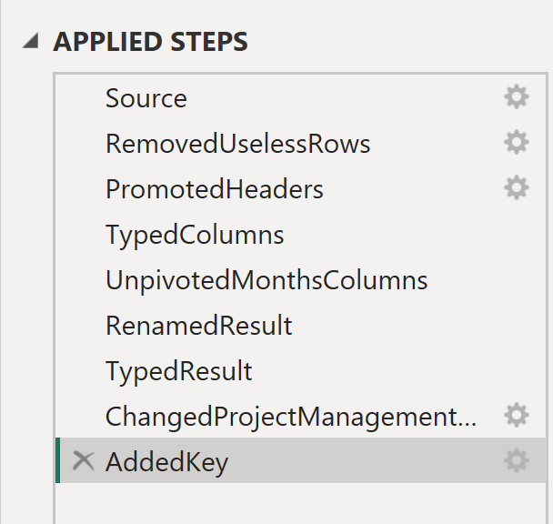 | Forecast  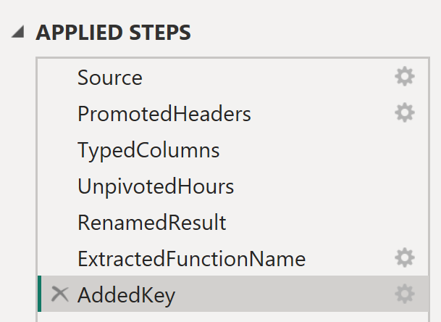 | Workload (Combination of Forecast & Typology)  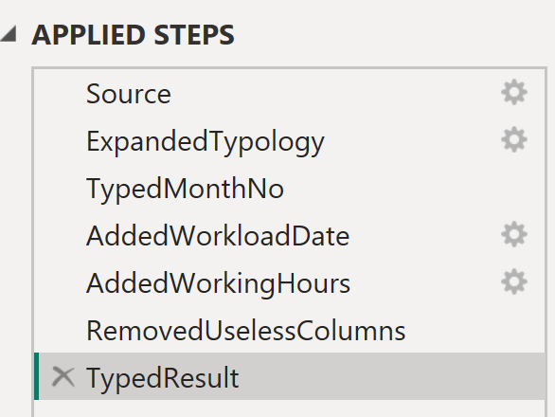

End Result
Your end result in PowerBI should look something like that:

Key Takeaways
- Practice using Merge and Unpivot together to build analytical-friendly data.
- Learn how to apply business logic through calculated columns in Power Query.
- Build a foundation for resource forecasting dashboards by role or department.

